**Spring 2016 MT2: Heaps and Balanced Trees**

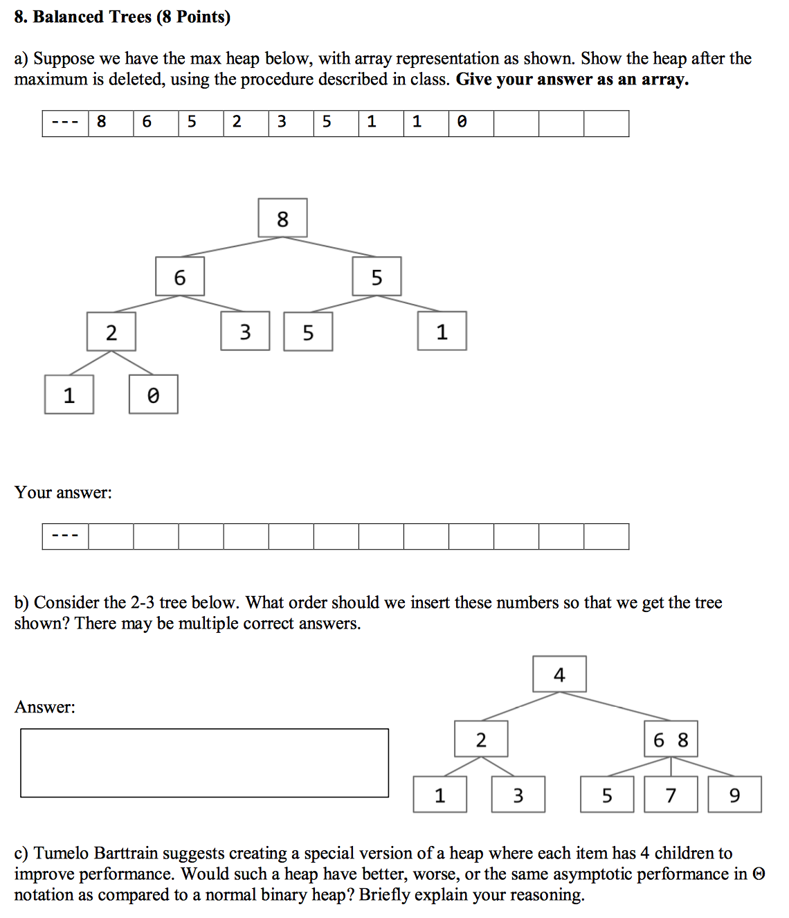

**Spring 2016 Final: Heaps and Testing**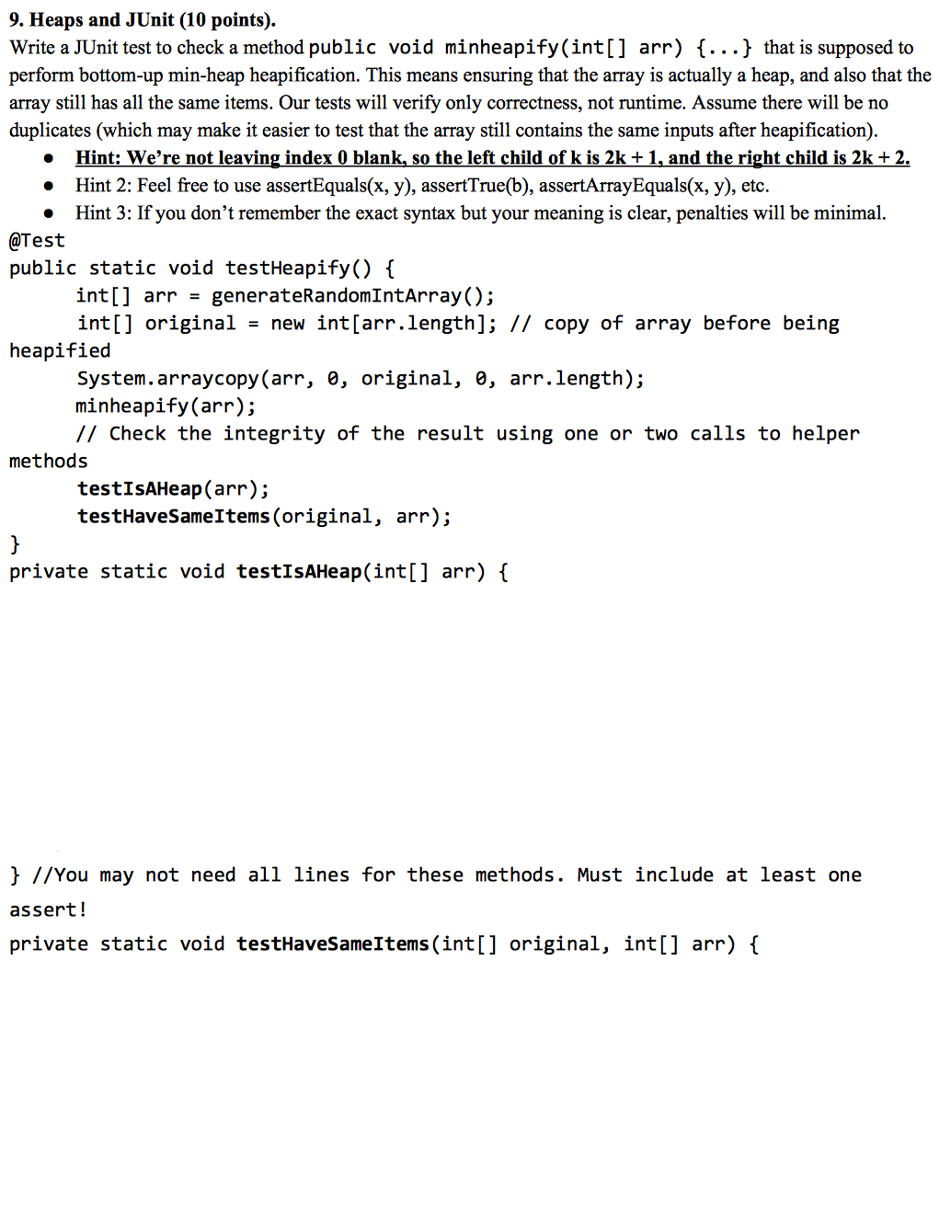

**Spring 2016 Final: Sorting and Trees**

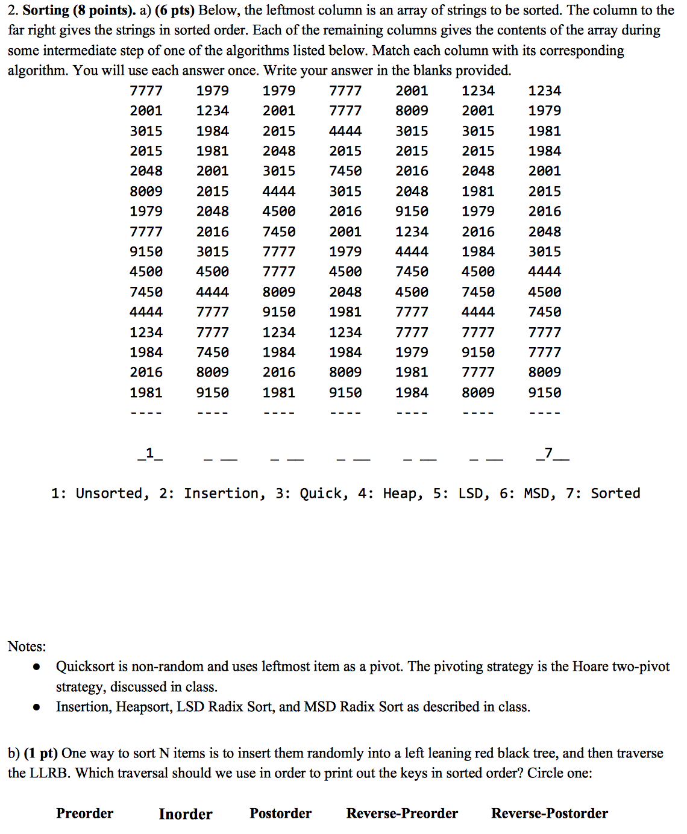

**Spring 2015 Final: Trees, Sorts, Best and Worst** 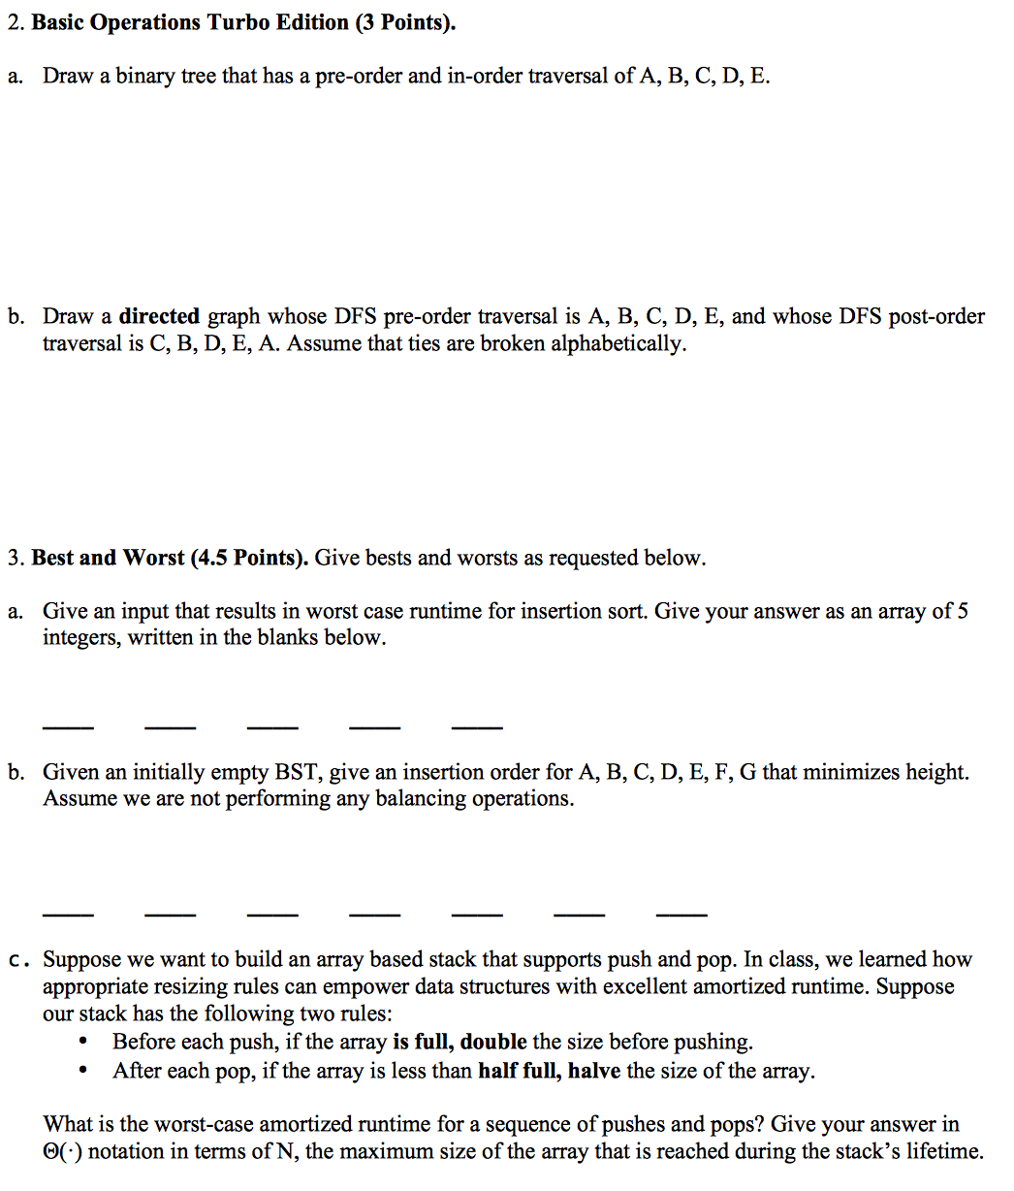

**Spring 2015 Final: Data Structures and Algorithms**

